## User manual for the Offline Client

When you open the program, you will be presented with a dialog where you can type in your username.

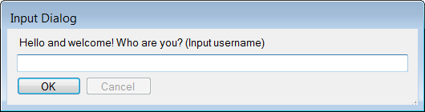

You will then be shown the main window of the offline program. You can select the projects you have downloaded in the dropdown box in the top of the window. When you select a project, the documents and folders of the project will be shown in the window. From here you can manage your existing documents and folders or create new documents and folders.

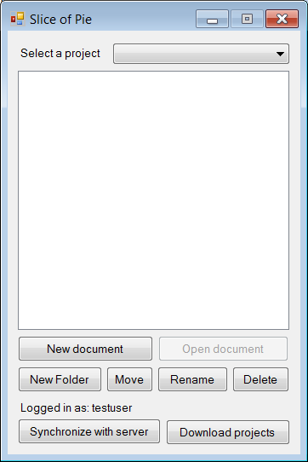 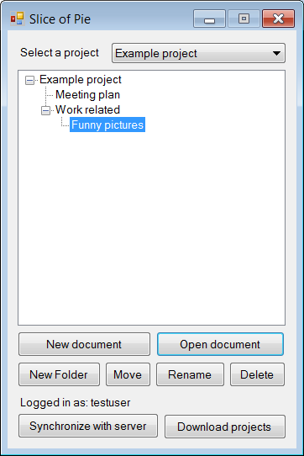

The “Synchronize with server” button will contact the server and upload your changes to the project to other users, as well as get the changes to the project from the other users. If you need to download a project that was created using the web interface, use the “Download projects” button.

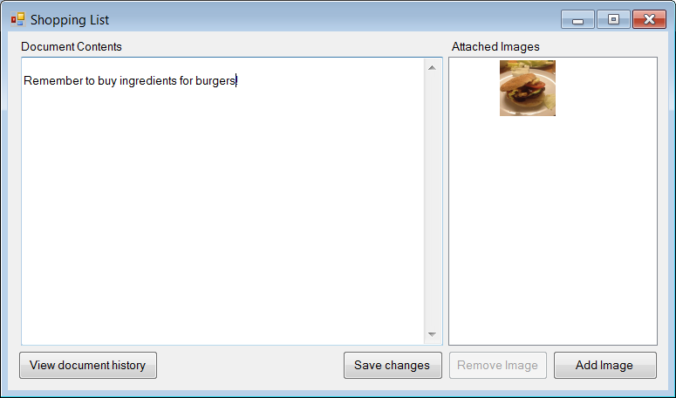

This is the screen that will show when you open a document. You can edit the contents of it, as well as manage the attached pictures. Remember to press “Save changes” after you are done editing the document.

If you need to see what changes that have been made to the document, use the “View document history” button. In here you can see a list of changed all users have made to this document.